Supplementary Materials: Children’s Generic Interpretation of Pretense

Materials used in Experiment 1

Animals |  | 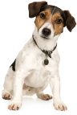 |  |  | 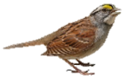 | 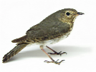 | 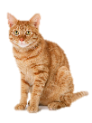 | 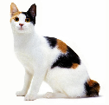
Objects (Pretense only) | 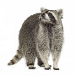 | 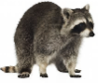 | 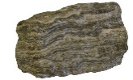 | 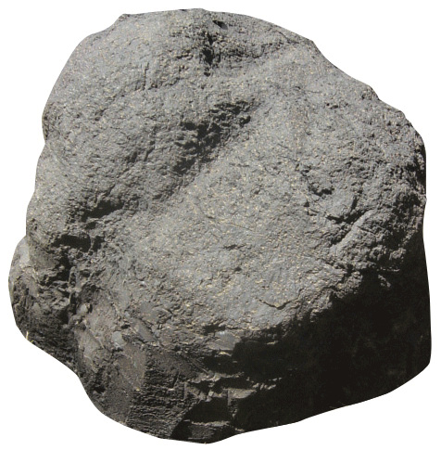 | 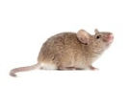 |  | 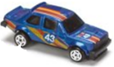 | 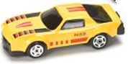

Materials used in Experiment 2

Animals
Pretend
Non-generic Language | 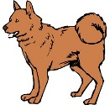 | 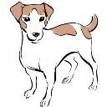
Objects
Pretend
Non-generic Language | 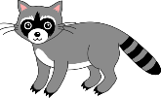 | 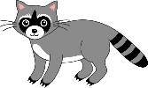 | 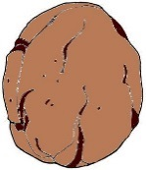 | 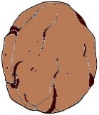 | 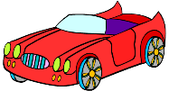 | 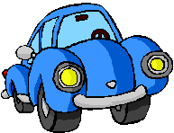

Table 1: Counts of usable trials in Experiments 1 & 2

 | 4 | 3 | 2 | 1 | 0
Experiment 1
Younger
Pretense | 14 | 2 | 2 | 2 | 3
Non-generic Language | 15 | 2 | 2 | 2 | 0
Older
Pretense | 18 | 2 | 0 | 0 | 0
Non-generic Language | 14 | 3 | 1 | 1 | 2
Experiment 2
Younger
Pretense |  | 14 | 4 | 3 | 5
Non-generic Language |  | 20 | 2 | 3 | 3
Older
Pretense |  | 21 | 4 | 2 | 0
Non-generic Language |  | 16 | 2 | 3 | 5
*Note: There was no fourth trial in Experiment 2.

Table 2: Counts of additional variables in Experiments 1 & 2

 | Valid Responses | Irrelevant Responses | Follow-Up Questions | Total Trials
Experiment 1
Younger
Pretense | 68 | 22 | 30 | 92
Non-generic Language | 72 | 8 | 21 | 84
Total | 140 | 30 | 51 | 176
Older
Pretense | 78 | 8 | 5 | 80
Non-generic Language | 68 | 19 | 21 | 84
Total | 146 | 27 | 26 | 164
Grand Total | 286 | 57 | 77 | 340
Experiment 2
Younger
Pretense | 53 | 24 | 33 | 78
Non-generic Language | 67 | 19 | 30 | 84
Total | 12 | 43 | 63 | 162
Older
Pretense | 73 | 13 | 16 | 81
Non-generic Language | 55 | 26 | 38 | 78
Total | 128 | 39 | 54 | 159
Grand Total | 236 | 82 | 117 | 321
*Note: Numbers will not add up to the total column because of categorical overlap.

